Manual for Interactive Case Study Simulations
in Educational Leadership
(version 1.0)

Thomas Valesky
Florida Gulf Coast University
Copyright © 2003

Table of Contents:

Introduction and Brief Overview of Each Simulation ……………………… 2

How to Use The Interactive Simulations …………………………………… 3

Detailed Explanation of Each Simulation …………………………………… 5

A Brief Review of Problem Analysis in Decision Making .………………. 8

Recommended Readings ……………………………………………………. 14

Introduction and Brief Overview of Each Simulation

These simulations will work on both Macintosh and PC computer types. You do not need special software or hardware to use these simulations. If you have problems loading a simulation, perhaps you have insufficient RAM available. If this happens, close all other programs and try again.
The three simulations can be used by a professor in either a large class setting or with small groups of students in cooperative learning groups. It is recommended that professors supplement the discussion questions that are posed in the simulations with questions and discussion items that are of local importance in your state and local school districts.
There is no order suggested for using the simulations. These were developed for a class at Florida Gulf Coast University entitled Case Studies in Educational Leadership, but they can be used in any class depending on the class topic. Below is a brief description of the three simulations including a list of topics appropriate for discussion. A more detailed description of each simulation is provided in a later section of this manual:

The Case of the Stolen Radio: In this case, a student’s walkman-type radio is stolen from him on a school bus.
- Topics: school law (search and seizure); dealing with angry parents.

The Recalcitrant Teacher: Some teachers complain to the principal about another teacher who is consistently late in picking up her students from special classes, late to meetings….you get the picture. The principal has to decide how to handle this teacher.
- Topics: personnel problems; teacher records; communicating with teachers.

Breaking Up is Hard to Do: A Regular Education Teacher Breaks Up a Fight in an Inclusive Classroom: One special education student and one regular student in an inclusion classroom get into a fight. A variety of different versions of the fight is presented--each of which leads to different problem solving opportunities.
- Topics: student discipline problems; inclusion; special education law; communicating with parents.

How to Use the Interactive Simulations

The user interface for each simulation essentially works in the same way. Here is a typical screen that you will see, with additional explanation on the next page:
This title tells you in which part of the simulation you are working.
Directions, comments from the narrator, questions to answer or choices for you to select a response, which will take you to another video or text screen.

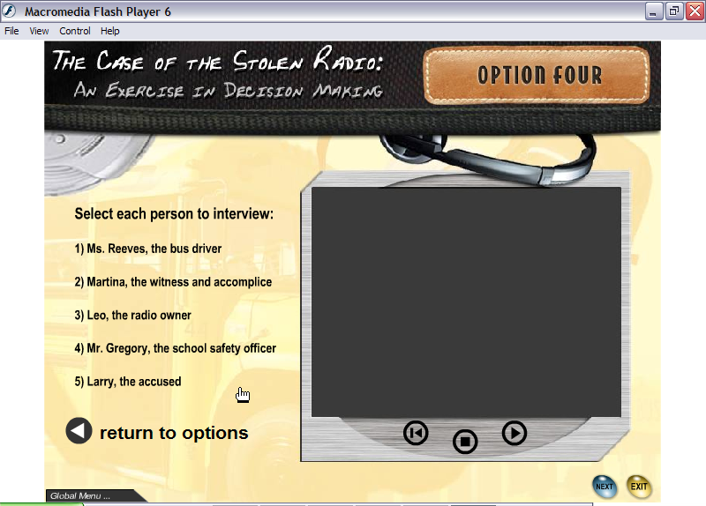

TV Buttons:

Rewind
Pause/Stop
Play
User control buttons.
Global menu. Click here and you can go to any option or screen in the simulation.

Explanation of Screen Items:

- On the top left of the screen you will view some text. It will contain one or a combination of the following items:
  - Instructions from the narrator.
  - Questions that you should consider and discuss.
  - Responses or choices that you make to answer questions. This will take you to another screen.
- Click on the Global Menu at the bottom left of the screen to open it. To lower the menu, simply click on it once again. It will not disappear until you click again. The Global Menu allows you to go to any screen in the simulation that you choose. For example, you are watching a video in “Option 2,” but you can’t remember everything that was said in the “Critical Incident” Video to make your decision. In this case you can use the Global Menu perhaps to navigate back to the Critical Incident video before making a choice.
- The TV screen has been made large to provide for the best viewing, while not so large that it takes up too much computer memory. To control the videos, you may click on the buttons to play, pause, or rewind and play again if you want to review the video. Video clips are no more than a minute each.
- Finally, there are sets of buttons on the lower right of the screen that allow you to do several things. For example, you can skip ahead to the “Next” screen, you can “Exit” the program when you are finished using the simulation, or other options may be presented for you to control. You can
- “Exit” the simulation at any time by clicking on the “Exit” button at the lower right. If you have not yet finished the simulation, you can always come back to where you left off by using the Global Menu.

Detailed Explanation of Each Simulation

The Case of the Stolen Radio
- Topics: school law (search and seizure); dealing with angry parents. Students using the simulation should have search and seizure guidelines from your state or local school district for discussion purposes.

In this case, a student’s walkman-type radio is stolen from him on a school bus. Another student, Larry, is accused of the theft. The bus driver cannot resolve the problem, so she calls ahead to the school where two teachers who are called “School Safety Supervisors” are waiting to meet the bus. The “Critical Incident” in this simulation is a video clip that occurs on the bus, where one of the teachers, Ms. Davos, asks all students to file out and open their bags for her to look inside.
After Larry walks out of the bus, he is spotted outside a bus window where someone hands him a bookbag. The other teacher, Mr. Gregory, and the School Resource Officer (a city policeman) stop him. You are now given four options of what you would do if you were Mr. Gregory.
Option 1: Grab the gym bag from the student and search it on the spot.
Option 2: Walk the student up to the office to see the assistant principal and turn the decision over to her.
Option 3: Turn the matter over to Officer Hays, the School Resource Officer, for potential use in criminal prosecution.
Option 4: Do nothing and allow the student to leave with the bag. Then turn over the investigation to the assistant principal to let her decide what to do.

After deciding what you would do, click on that option. Each Option provides you with another video which leads to additional decision-making opportunities. Follow the narrator’s directions and the screen option available to you.
After completing your first option choice in the simulation, it is recommended that you return to each of the original four option choices and review the content of each for additional problem solving and discussion opportunities.

The Recalcitrant Teacher
- Topics: personnel problems; teacher records; communicating with teachers. Students using this simulation should have access to documents from their school district or state regarding teacher personnel files and record keeping. In addition, it might be helpful to have a copy of a teachers’ policy manual from a local school district handy for discussion.

This is typical personnel problem that a principal might face in any school. In the critical incident, some teachers discuss another teacher with whom they are unhappy. One of these teachers, the physical education teacher, then complains to the principal about the behavior of Janet Shane who “didn’t pick up her kids twice this week. She does this all the time.”
After the critical incident, you are presented with several options that principals are likely to do. A student in graduate classes in Educational Leadership would never consider some of these options, but in fact, these behaviors do occur in the real world. They are presented here for you to reflect upon and consider the consequences of such behaviors. Each of the options will lead to subsequent video clips and/or discussion questions.
First, choose the option that you believe would be the first, best option. Then consider all of the other options in any order to experience the decisions available and to reflect upon the potential consequences of such behaviors.
Option 1: Delegate the task to the assistant principal.
Option 2: Ignore the problem, but keep an eye on the teacher.
Option 3: Have a conference with the teacher and discuss potential disciplinary action.
Option 4: Delegate to the guidance counselor, who is a good friend of Janet Shane.
Option 5: Read a memo at a faculty meeting about all teachers’ responsibilities, including picking up their students from special classes.
Option 6: Place a memo in every teacher’s mailbox about teachers’ responsibilities.
Option 7: Send a personal letter of reprimand to the teacher.
Option 8: Talk to other teachers to confirm Janet Shane’s behavior.

Breaking Up is Hard to Do: A Regular Education Teacher Breaks Up a Fight in an Inclusive Classroom
- Topics: student discipline problems; inclusion; special education law; communicating with parents. Students using this simulation should have access to special education law resources, and local policies and procedures for dealing with special education students.

One special education student and one regular student in an inclusive classroom get into a fight. There is a regular and a special education teacher assigned to this classroom during the fight, but the special education teacher is out making student instructional material at the time of the fight. A variety of different versions of the fight are presented--each version leads to different problem solving opportunities. Each of the fight scenarios has a different result, and you will be presented with either subsequent video clips and/or discussion questions after each scenario. The different scenarios involve the follow outcomes:
Scenario 1: The regular education teacher, who is pregnant, gets hit while trying to break up the fight. The scene moves to the principal’s office where the regular and special education teacher meet with the principal. The principal is left with two options from which you may choose:
Option 1: Suspend both students.
Option 2: Suspend only the regular education student.
Scenario 2: In this scene, the regular education teacher tries to break up the fight and accidentally tears the shirt of the special education student. You are then provided with some questions to consider about how the principal should respond about the torn shirt.
Scenario 3: The special education student gets punched in the nose, while the regular education teacher awaits the arrival of the special education teacher. The scene changes to the principal meeting with the mother of the special education student who is upset about her son getting hurt while the teacher stood by and did not intervene.
Scenario 4: The special education teacher enters the room and breaks up the fight by restraining the special education student. The scene fades to the principal’s office where the teachers and the principal discuss policies about dealing with special education students in an inclusive classroom.

A Brief Review of Problem Analysis and Decision Making

For this review, I will treat the terms “Problem Analysis” and “Decision Making” synonymously, though Problem Analysis is a more recent term and is sometimes used in a broader context. The steps in a rational decision making model might look like the following:

- Identify the problem.
- Analyze the problem.
- Determine the optimal result or objective to be achieved.
- Generate alternative solutions to the problem.
- Determine which of the alternatives will best solve the problem, by identifying the intended and unintended consequences.
- Implement the optimal alternative. Provide the leadership and resources needed.
- Evaluate both the result and the implementation of the decision.

This is the classical decision-making model. Decision-making theory has been studied intensely by writers and researchers. Some of the early work of note for Educational Leadership was by James March and Herbert Simon (1958) who wrote about the “rational man” who would use classical decision theory to make optimal decisions. However, they state that the rational men of economics and statistical theory can do so because their choices are made in a highly specific and clearly defined environment. But the “administrative man” as they called the manager in an organization does not necessarily have a highly specific and clearly defined environment in which to make decisions. The administrative man deals with other humans where an objective environment in which to make decisions becomes difficult. Therefore “rational” becomes relative to some frame of reference. This frame of reference can be thought of as a “satisfactory” decision rather than “optimal” in what has become known as the principle of satisficing.
This principle of satisficing certainly applies to schools, where most decisions involve people. Decision makers cannot always know all of the alternatives available, cannot know all of the possible consequences of implementing each alternative, and hence, cannot know the optimal alternative. Simon (1997) called this “bounded rationality,” in that there are bounds or limits to the decision makers’ abilities to make optimal choices.
Less attractive words have been coined to describe the principle of satisficing. Lindblom (1959; 1993) indicates that this type of decision-making leads to “muddling through.” Lindblom called this “incremental” decision-making in which decision makers do not list all alternatives and their consequences. They limit the alternatives and limit the analysis of alternatives and consequences until the decision makers arrive at a decision with which they can agree. Cohen, March, and Olson (1972) used the phrase “garbage can model of decision making.” They state that because goals are unclear and often conflicting, and methods for achieving goals are not agreed upon by everyone, it is not possible to use the classical decision-making model in education. Into the garbage can, school decision makers deposit problems, alternatives, as well as the decision makers themselves where this mixture leads to a decision model that cannot follow the classical model.
Vroom and Yetton (1973) took decision-making models in a different direction by focusing on the amount of participation by others in a decision depending on different situations. Their model suggests that there are five primary decision-making styles. In the model, the letters mean “Alone” (AI, AII), “Consultative” (CI, CII), and “Group” (GII). One style (GI) has been left out purposely by Vroom and Yetton as outside the scope of most organizations (Vroom 1973):

Style I or AI: You solve the problem or make the decision yourself, using information available to you at that time.
Style II or AII: You obtain the necessary information from your subordinates(s), then decide on the solution to the problem yourself. You may or may not tell your subordinates what the problem is in getting the information from them. The role played by your subordinates in making the decision is clearly one of providing the necessary information to you, rather than generating or evaluating alternative solutions.
Style III or CI: You share the problem with relevant subordinates individually, getting their ideas and suggestions without bringing them together as a group. Then you make the decision that may or may not reflect your subordinates’ influence.
Style IV or CII: You share the problem with your subordinates as a group, collectively obtaining their ideas and suggestions. Then you make the decision that may or may not reflect your subordinates’ influence.
Style V or GII: You share a problem with your subordinates as a group. Together you generate and evaluate alternatives and attempt to reach agreement (consensus) on a solution. Your role is much like that of chairman. You do not try to influence the group to adopt “your” solution and you are willing to accept and implement any solution that has the support of the entire group.

To determine the type of style you would use for a specific problem, the Vroom and Yetton model. This model asks seven questions which follow a Decision Tree (see Figure 1). Depending on your answers to the questions you follow the tree’s path that ends with a choice of decision-making styles that you would use. The Vroom and Yetton model is particularly useful to schools because it guides decision makers to a style of deciding that may, or may not, involve others in the making a decision.

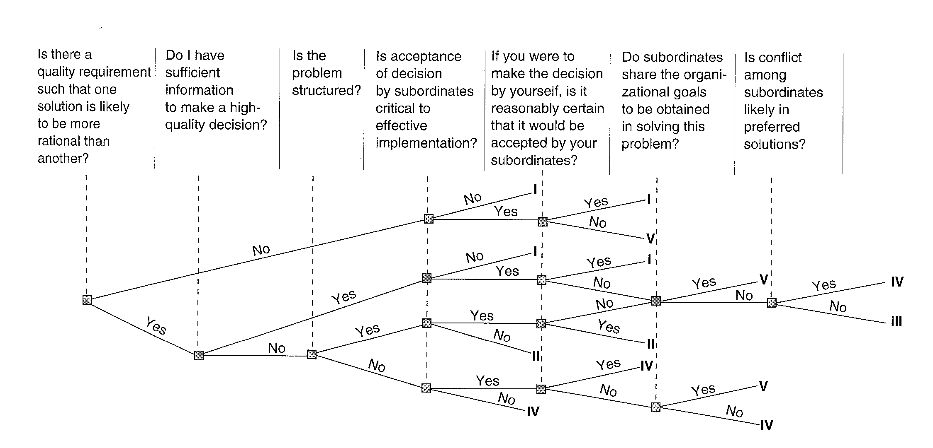

Figure 1. Vroom and Yetton’s Decision Tree. From Luthans, F (1977). Organizational Behavior (2nd ed.). New York: McGraw Hill, p. 458. Reproduced with permission from McGraw Hill.

Valesky, Horgan, Caughey, and Smith (2003) used the Vroom and Yetton model as a basis for their model of decision making for schools that use School-Based Decision Making (SBDM). For a technical description on the development of this model see Horgan and Valesky (1993).
SBDM is also called Site-Based Decision Making. Some equate Site-Based Management (SBM) with SBDM, although Valesky et al. differentiate SBDM and SBM. They state that SBM is a broader organizational leadership term that decentralizes additional authority to school sites where principals gain additional power, but it does not necessarily include shared decision-making--though it certainly can. SBDM is a formally recognized inclusionary process in which school districts distribute additional decision-making authority to schools, such as in budgeting and personnel, and then at the school level, administrative site councils are elected or appointed to include parents, teachers, administrators, and sometimes students.
The decision-making model proposed by Valesky et al. is a research-based model in which data were collected over a four-year period on actual decisions made in schools using SBDM. Then using Vroom and Yetton’s original model, the original seven questions were examined in light of their usefulness in making successful decisions in SBDM schools. Some of Vroom and Yetton’s questions were eliminated and others added to arrive at the final TTS model (Total Teamwork System) of decision-making. A flowchart of the model is presented in Figure 2.
In the TTS model, after deciding that a problem exists, there are four primary questions that must be answered (Valesky et al., 2003, 8-12):

1. Is this an issue or question that falls within the legitimate domain of your group?
Your decision at this point is whether this issue is within your domain. Is this something that your group should be dealing with? Is it something that is within your authority? Or is it something that is regulated by law? Or is it something that should be left to individual teachers? Groups often err by tackling decisions that are not theirs to make.

2. As stated, is this issue appropriate for a meaningful discussion? Should the question be rephrased?
Next, the TTS model includes a stage during which the problem/issue is narrowed, specified, and/or clarified. This specification and/or clarification is done before debate or discussion. Sometimes issues are too broad or contain sub-issues. They may need to be broken into components or narrowed to focus on only one issue. Often they need to be brought to a more specific level. Other times, issues deal with day-to-day procedures and need to be rephrased into a policy question. Try to rephrase the issue into a Yes/No format.
3. In order to deal effectively with this issue, would we seek further information?
Once you have stated the question to be decided in a form that is appropriate for the group to work with, you must decide if you have sufficient information to make a decision. There’s no point in wasting time discussing what to do if you lack the necessary information.

4. Is acceptance of a decision by people outside the committee necessary for successful implementation of the decision?” Will people outside the committee have to carry the decision out? If their participation will be mandatory and they must accept the decision in order for it to be successful, then the answer should be “yes.”

If the answer to this last question is “yes,” then you can still make the decision as a committee if you believe that you represent the views of your constituents. If you aren’t sure if you represent their views, or if their views are very divergent, then you need to bring others into the decision-making process and reach a decision through consensus, if possible.
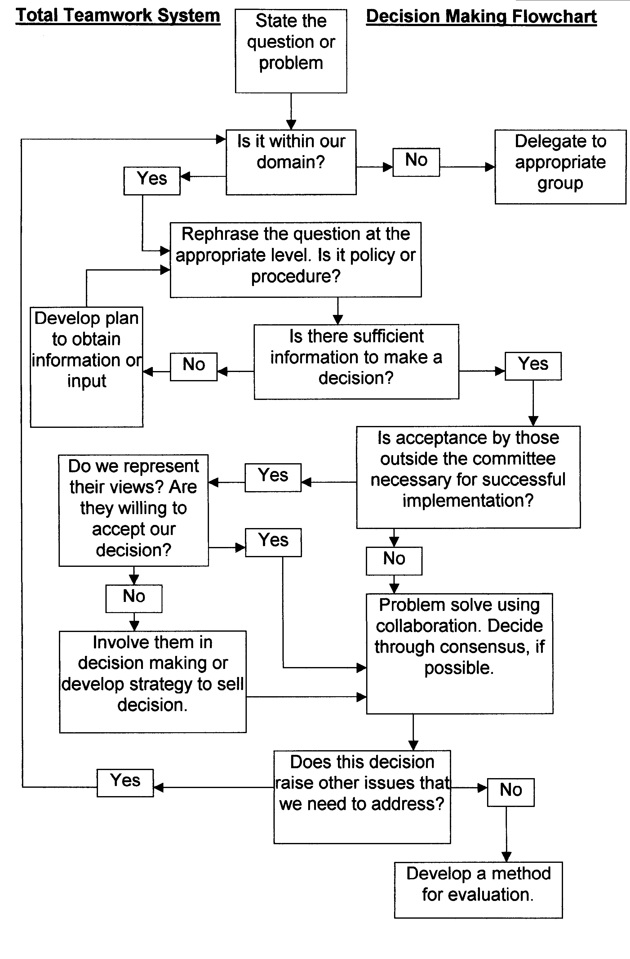
Figure 2. TTS Model of Decision Making

For these simulations, it is recommended that some type of satisficing model be used that combines some elements of the classical model, Vroom and Yetton’s model, and the TTS model. It might look something like this:

- Identify the problem. Determine if there is more than one problem and state the problem or problems specifically.
- Analyze the problem or problems and determine if they need to be solved separately. If so, write down each problem to be solved and go through the decision making process for each problem.
- Use Vroom and Yetton’s Decision Tree to determine if others should be involved (GII of their model).

If Style V (GII) is chosen, then go to number 4 below; if not, skip 4:
- If others will be used to share in the decision making (GII), then enter the TTS model at the second box “Is It Within Our Domain?” and use the rest of the model to make your decision.

If the Vroom and Yetton Decision Tree leads you to any of the other alternative styles (I-IV), then continue with your problem solving here with number 5:
- Determine the result or objective that will satisfy the accomplishment.
- Generate alternative solutions to the problem.
- Determine which of the alternatives will best solve the problem, by identifying the intended and unintended consequences.
- Implement the alternative that will best satisfy the problem. Provide the leadership and resources needed.
- Evaluate and reflect both the result and the implementation of the decision.

Obviously you may use any one of the models, or a combination of the models that suits your needs. The model you choose however should be well thought out to insure that you arrive at a decision that satisfactorily solves your problem.
Recommended Readings and References

Achilles, C. M., Reynolds, J. S. & Achilles, S. H. (1997). Problem analysis: Responding to school complexity. Larchmont NY: Eye on Education.

Cohen, D. M., March, J. G., & Olsen, J. D. (1972). A garbage can model of organizational choice. Administrative Science Quarterly, 17,1-25.

Horgan, D. & Valesky, T. (1993). Empirically based training for school-based decision making. National Forum of Educational Administration and Supervision Journal, 10(3), 3-15.

Lindblom, C. E. (1959). The science of muddling through. Public Administration Review, 19, 79-99.

Lindblom, C. E. (1993). The science of muddling through. New York: Irvington publishers.

March, J. G. & Simon, H. A. (1958). Organizations. New York: John Wiley and Sons.

Simon, H. A. (1997). Models of bounded rationality: Empirically grounded economic reason. Cambridge MA: Massachusetts Institute of Technology Press.

Valesky, T., Horgan, D. D., Caughey, C. E., & Smith, D. L. (2003). Training for quality school-based decision making: The Total Teamwork System. Lanham, MD: The Scarecrow Press.

Vroom, V. & Yetton, P. (1973). Leadership and decision-making. University of Pittsburgh Press.

Vroom, V. (1973). A new look at managerial decision making. Organizational Dynamics, 2(1), 66-80.

